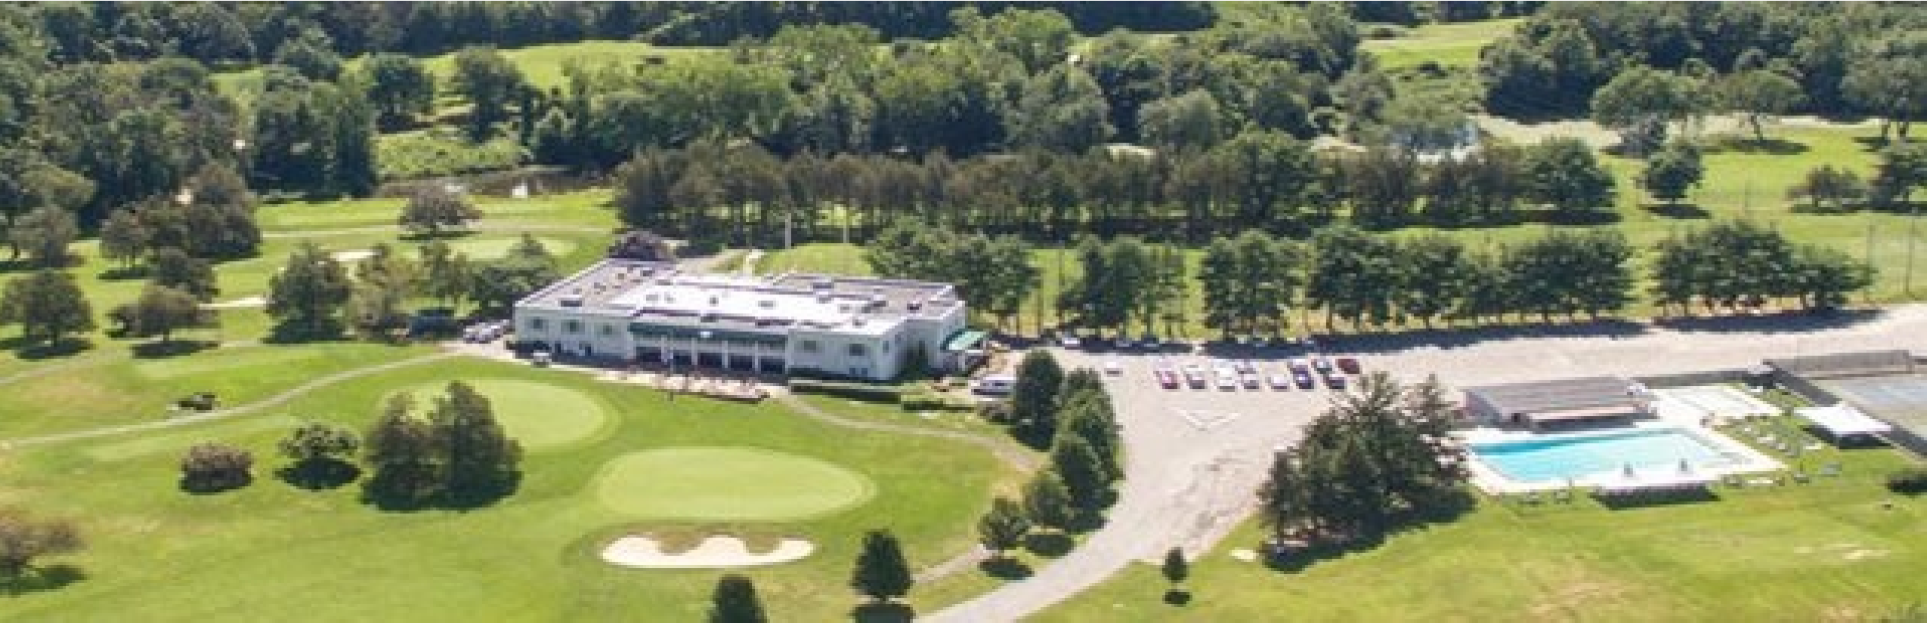

**th Annual**

**12**

**Ulster Fillies Golf Outing**

**Wiltwyck Golf Club**

**Saturday May 15th, 2021**



(404

Steward Lane, Kingston, NY

)

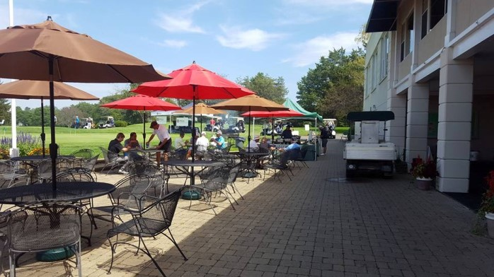

Captain and Crew format (4 players)

holes, free range balls

18

Beer on course, dinner following play with cash bar

Check in with lunch: 12:30pm-1:30pm

Shotgun Start: 1:30pm

Cost: $450 per foursome or $125 individually

Raffle, 50/50, mulligans and putting green contest

Prizes award to first, second and third place teams. Long drive and closest to the pin (mens and womens)

Contact Rick Spriggs at (845)399-8162 – [spriggsrick@yahoo.com](mailto:spriggsrick@yahoo.com) or Chuck Veach at (845)206-6732 – cwv1880@yahoo.com for more information.

**Team Sign Up Sheet**

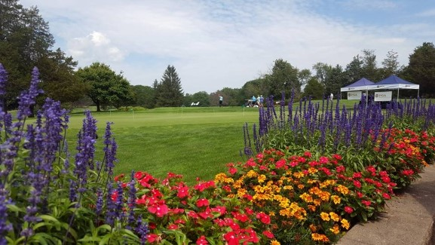

**TEAM Contact # - ________________________________**

Player #1 (Captain)________________________________

Player #2________________________________________

Player #3________________________________________

Player #4________________________________________

Name of Fillies player supporting_____________________

***Please make checks payable to the Ulster Fillies (due with registration).

The Ulster Fillies would like to thank all of those who will be participating in the event. Our longstanding organizational

policy is the development of these young ladies into not only top notch softball players, but into proud representatives of

the community. This is not possible without your support.

**Wiltwyck’s golf course was designed by Robert Trent Jones and**

**is widely recognized as a significant test of championship golf.**

**Wiltwyck is the area’s premier course. Come out and play it**

**while supporting a great cause, the Fillies players and their families!**